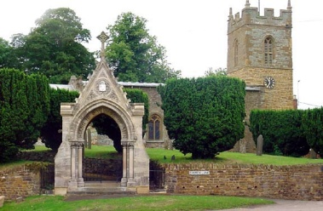
COLD ASHBY
ANNUAL PARISH ASSEMBLY
Wednesday 15th May 2019

The annual Cold Ashby Parish Assembly will take place on Wednesday 15th May at 7.30 p.m. in the Village Hall.
Everyone on the electoral register for Cold Ashby is welcome to attend. The meeting provides an opportunity to discuss matters of common or individual interest relating to the welfare and development of our community. Anything decided formally at the meeting will be reported directly to the relevant local bodies, including the Parish Council, and will carry the weight of a resolution from an officially constituted meeting.
Agenda
1. Election of chairman for the meeting (if the Parish Council chairman is present he will assume the chair automatically)
2. Apologies for absence
3. Minutes of the 2018 assembly
4. Welcome and introduction – the chairman will explain the purpose and nature of the meeting.
5. Chairman’s report – the chairman of the parish council will give a brief report on the work and achievements of the council in 2018-19 and look forward to activity in the coming year.
6. Cold Ashby Parish Environment Group (Capeg) – general discussion
7. Police and Community Support Officer – discussion on feasibility in Cold Ashby
8. Street lighting. Plans and progress on streetlight replacements in Cold Ashby
9. Cemetery: residents views on maintenance and regulations, including pricing, are sought
10. Bus Service: information on latest position and an opportunity to raise issues.
11. Councillor Vacancy
12. Reports from District and County Councillors if present
13. Open Forum – an opportunity to raise further matters of general or individual interest relating to the community.

G Jones
CAPC clerk May 2019

